

RELOD SELT
Level: 0
(Young Learners A1-)
DEMO

TIME ALLOWED:
SECTION A (LISTENING): APPROX 15 MINUTES
SECTIONS B&C (READING, ENGLISH USAGE, WRITING): 30 MINUTES

INSTRUCTIONS TO CANDIDATES:
- Answer all the questions
- Transfer your answers to the Answer Sheet

RELOD «Russian & English Languages Open Doors», 2010
ISBN 9785899731020

SECTION A

LISTENING

Section A. Part 1 (5 questions)

Прослушай текст и укажи номера, обозначающие тех, о ком говорится в тексте.
Один номер уже указан в качестве примера.

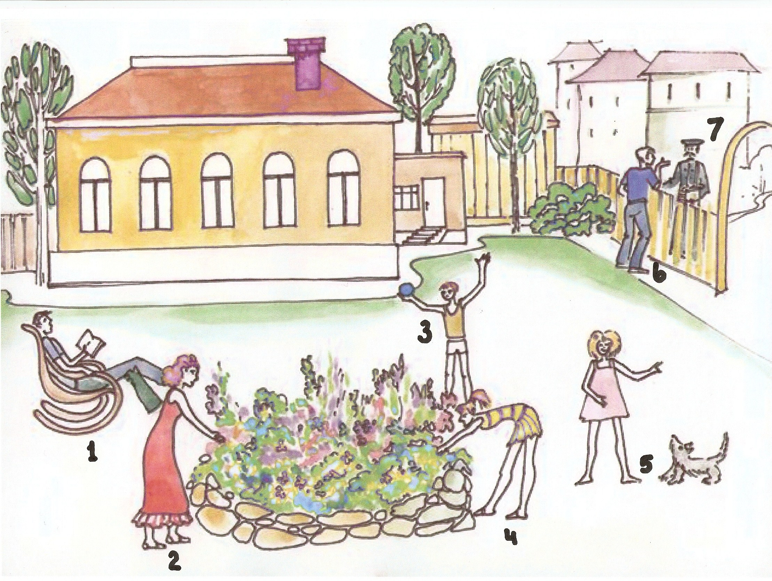

B0 | B1 | B2 | B3 | B4 | B5
Tom | Anna | Peter | Tom’s father | Tom’s mother | Alice
3

Section A. Part 2 (5 questions)

Прослушай диалог. Прочти утверждения и определи, какие из них правильные, а какие – нет. Напиши напротив каждого утверждения Yes или No. Первые два ответа даны в качестве примера. Ты услышишь текст два раза.

Examples:
Mark’s favourite kind of sport is tennis. ……….…..... ________Yes____________

Mark plays it four times a week. ……………………… ________No____________

B6 At weekends Jim usually goes to the swimming pool…… _______________________
B7 _______________________
B8 _______________________
B9 _______________________
B10 _______________________

Section A. Part 3 (5 questions)

Прослушай каждый диалог и отметь ту картинку из трех, которая отражает содержание текста. В квадратике можно поставить галочку или крестик.

A1 Who is the doctor?

 | 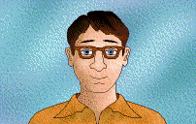 | 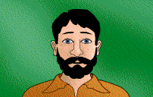
A. □ B. □ C. □

A2 At what time does Kate usually come home?

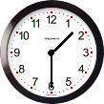 | 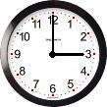 | 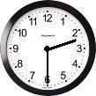
A. □ B. □ C. □

A3 What did Lily’s brother give her for her birthday?

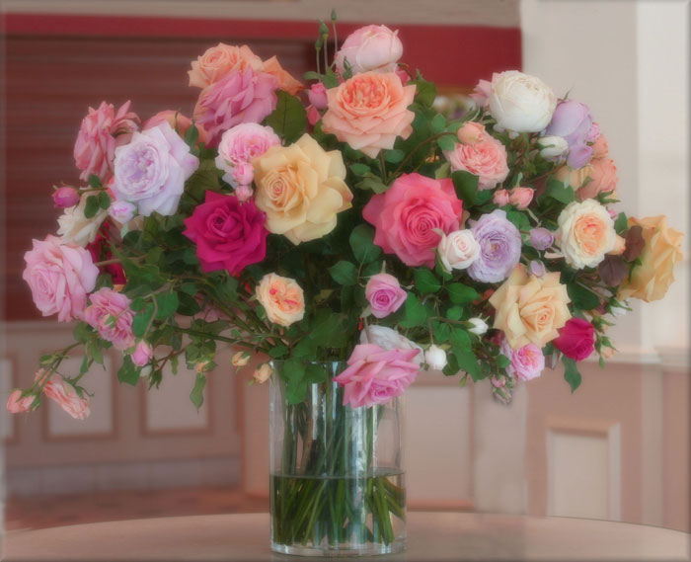 | 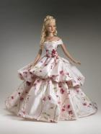 | 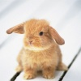
A. □ B. □ C. □

A4 What pet has Simon got?

 | 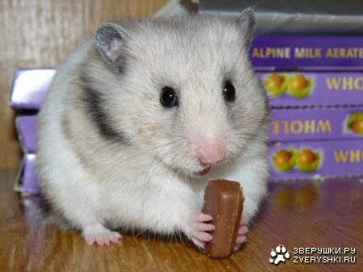 | 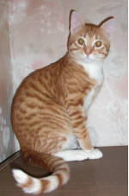
A. □ B. □ C. □

A5 What is Jane going to buy?

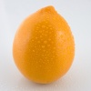 |  | 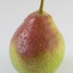

A. □ B. □ C. □

ОКОНЧАНИЕ РАЗДЕЛА LISTENING
SECTION B

READING AND WRITING

Section B. Part 1. (5 questions)

Прочти определения внизу (B11-B15), подбери к ним правильные слова из рамки и впиши их в пробелы справа. Первое задание (0) дано в качестве примера. Три слова в рамке лишние!

  an elephant |  | 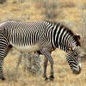  a zebra
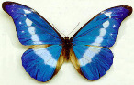
a butterfly
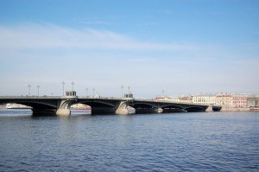
a bridge

Example:

(0) This is an insect with large bright wings. …….…… _______butterfly_________

B11 It is a very large, grey animal with a very long nose,
called a trunk and big ears…………………………….. _______________________
B12 It goes over a river, railway, or road, so that people or
traffic can get across, or under, or through. .…………… _______________________
B13
B14
B15

Section B. Part 2. (5 questions)

Прочти текст, затем прочти утверждения ниже и определи, какие из них правильные, а какие – нет. Напиши напротив каждого Yes или No. Первый ответ дан в качестве примера.

Kate’s Exam
Kate wake up and looked at the clock. “Oh no, it’s half past ten! I should be at school for
my Science exam,” she thought. Kate didn’t want to miss this exam because she knew it
was very important for her future. She wanted to become a dentist.
She got dressed quickly and ran to catch the bus. But it wasn’t her lucky day! It was foggy and the traffic was very slow. Kate waited for a quarter of an hour but the bus didn’t arrive “Oh no! I’ll be late for my exam,” she thought, and decided to take a taxi.
Kate arrived at school at midday. She saw her friends leaving the exam room and felt very unhappy. “I’m too late! I’ve missed the Science exam. I’ll never make it to university!’ she cried. Then, she heard Mrs Simpson, her science teacher, ask: “What’s the matter, Kate?”
“I was too late for the Science exam this morning. What am I going to do?” said Kate. “But the exam is tomorrow morning, Kate! Don’t you remember?” said Mrs Simpson.

Example:
Kate didn’t want to miss her exam because she was afraid of her teacher. No

B16 Kate had breakfast before going to school. ___________________
B17 ___________________
B18 ___________________
B19 ____________________
B20 ____________________

Section B. Part 3. (10 questions)

Прочти рассказ и вставь пропущенные слова. Впиши в пробелы только буквы (A, B, C или D). Первое задание (0) уже сделано в качестве примера.

My name (0) ______B______ Steve. I am 9 years (1) ______________. I like books and films (2) _______________ planes. …

Example:

0. A. am B. is C. was D. are

A6 A. young B. all C. new D. old
A7
A8
A9
A10
A11
A12
A13
A14
A15

ОКОНЧАНИЕ РАЗДЕЛА READING AND WRITING

НЕ ЗАБУДЬ ПЕРЕНЕСТИ СВОИ ОТВЕТЫ НА СПЕЦИАЛЬНЫЙ БЛАНК!

