

RELOD SELT

DEMO
Level: 2

(PRE-ELEMENTARY A1+)

TIME ALLOWED:
SECTION A (LISTENING): APPROX 15 MINUTES
SECTION B (READING & WRITING): 45 MINUTES

INSTRUCTIONS TO CANDIDATES:
- Answer all the questions
- Transfer your answers to the Answer Sheet

©RELOD «Russian & English Languages Open Doors», 2010
ISBN 9785899731037

SECTION А

LISTENING

Part 1 (5 question)

Прослушайте текст и сопоставьте имена людей с видом спорта, которым они занимаются. Напишите буква (A-F) рядом с именами. Название одного вида спорта лишнее!

B1 Tim __________________________
B2 Hannah ________________________
B3 David ________________________
B4 Juliet _________________________
B5 Joe __________________________

  A. tennis | 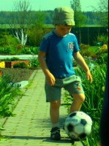  B. football
  \  C. chess |   D. hockey
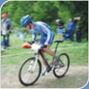  E. cyclist |   F. figure skater

Section A. Part 2 (9 questions)

Прослушайте диалог и ответьте на вопросы. Напишите цифры или Да/Нет на строчках, как в примере.

EXAMPLES:
Does Oliver work in Liverpool? _________Yes_____________
What time does Oliver catch the train in the morning? ________7.45_____________

B6 Does Oliver live in Bristol? _____________________
B7 ______________________
B8 ______________________
B9 ______________________
B10 ______________________
B11 ______________________
B12 ______________________
B13 _____________________
B14 _____________________
B15 ______________________
Section A. Part 3 (5 questions)

Прослушайте диалоги и выберете одну из картинок, чтобы ответить на вопрос.

A1 What chair did the customer choose?
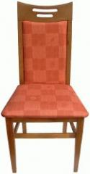 |  | 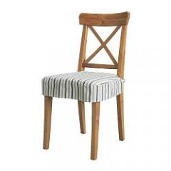
A □ B □ C □

A2 Which one is Judy’s umbrella?
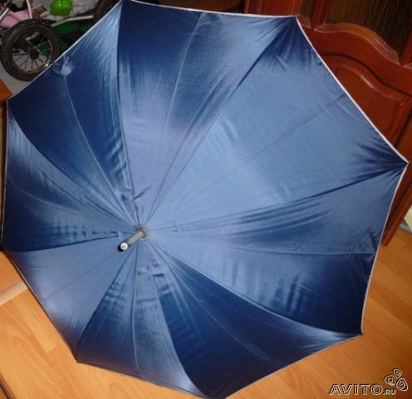 |  | 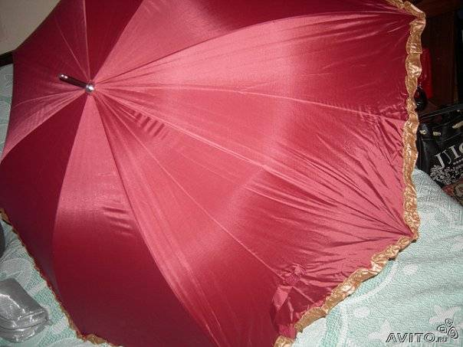
A □ B □ C □
A3 Where did Alice go?
 |  | 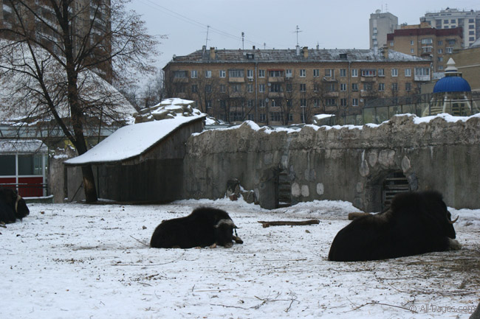
A □ B □ C □
A4 What did the customer buy?
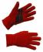 | 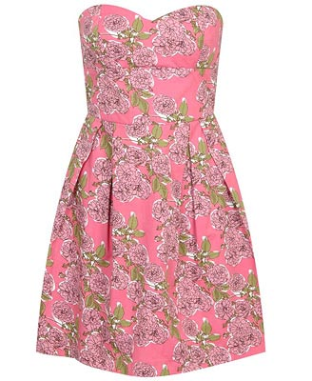 | 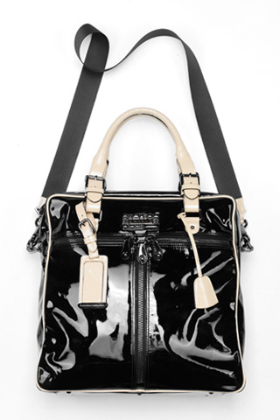
A □ B □ C □
A5 What did the customer ask to change?
 | 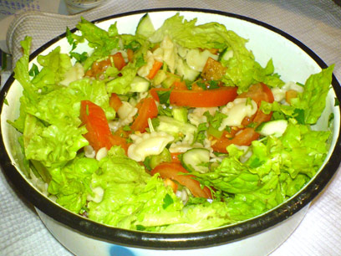 | 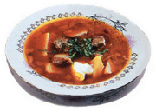
A □ B □ C □
THE END OF THE LISTENING SECTION

SECTION В

READING

Section B. Part 1 (5 questions)

Вопросы B16-B20. Прочитайте параграфы ниже и расположите их в правильном порядке (1-5). Перенесите ответы в ответный лист.

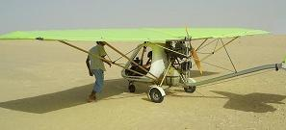
B16- Rick Anderson, a magazine photographer, had no idea what would happen to him when he set off over the Sahara Desert in a small plane last month. The view was beautiful, but the sun was boiling hot as the plane flew slowly over the desert.
B17

B18

B19

B20

Part 2

Прочитайте статью о и определите, какие утверждения верны (True), неверны (False). Если утверждение содержит недостаточно информации для ответа (Doesn't say).

Round the World
Jonathan and Claire Spencer both had very busy jobs and didn’t have enough time to spend with their young children. They wanted to change this, and because their hobby was boats, they decided to sail round the world together.
Example:
0 Before their trip, Jonathan and Claire Spencer Spent a lot of time working.
A True B False C Doesn’t say
A6
A7
A8
A9
A10
A11
A12

USE OF ENGLISH
Part 1 (8 questions)

Прочитайте статью о ящерицах и выберите наиболее подходящее слово (A, B or C) для каждого пропуска.

Lizards
Lizards are small reptiles. Most (A13)…………in warmer, drier parts of (A14)………. world, and can often be seen sunning (A15)………… or running away from danger.
(A16)……….. lizards have sharp eyesight and a good sense of hearing. They generally (A17)……….. on insects and other small animals. Lizard’s skin is silky smooth and their legs are small. Some have no legs at all.
Lizards have (A18)………… enemies. They protect themselves by moving (A19)………. and by camouflage. They match their environment and so are difficult to see. Some types of lizards shed their tails if caught by a predictor, and so escape. The tail will grow again.
Most lizards lay eggs, but some kinds (A20)…….. birth to live young.

A13 A lives B live C living
A14 A - B a C the
A15 A itself B ourselves C themselves
A16 A All B Every C Each
A17 A fed B feed C feeding
A18 A much B more C many
A19 A quickly B quick C quicker
A20 A gives B given C give

SECTION C
WRITING
C1

Прочитайте отрывок из электронного письма, полученного от английского друга Брайана. Напишите письмо и ответьте на его вопросы. Напишите от 50 до 70 слов.
I've just bought a mobile phone. It's great to call and send messages. How often do you call your friends? What else do you use your mobile phone for?
Write back soon,
Brian

НЕ ЗАБУДЬ ПЕРЕНЕСТИ СВОИ ОТВЕТЫ НА СПЕЦИАЛЬНЫЙ БЛАНК!

